NUCLEUS GTX | BLACK BEARING SEA | MNUCLEUSGTXBLKSEA | 219,95 €

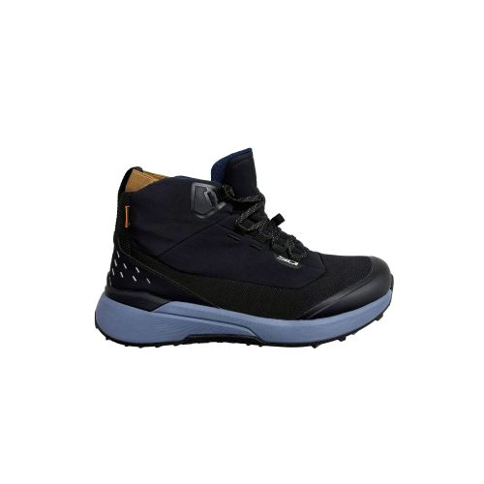
NUCLEUS GTX | BLACK WHITE | MNUCLEUSGTXBLKSWTE | 219,95 €
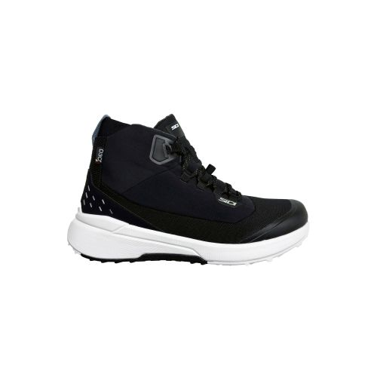
NUCLEUS GTX | IVY BLACK | MNUCLEUSGTXIVYBLK | 219,95 €

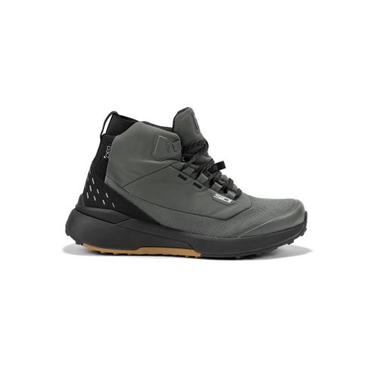
NUCLEUS SUEDE WP | BLACK WHITE | MNUCLEUSWPBLKWTE | 199,95 €
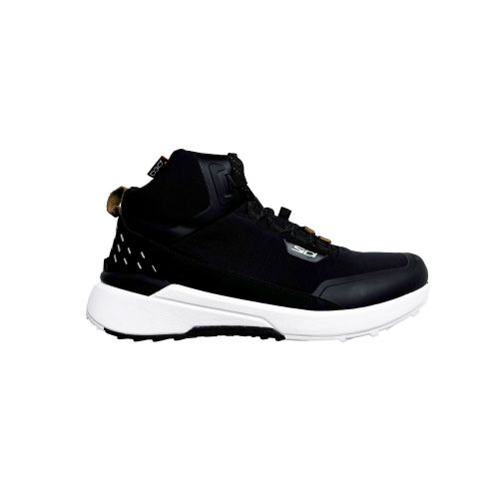
NUCLEUS SUEDE WP | BLACK IVY | MNUCLEUSWPBLKIVY | 199,95 €
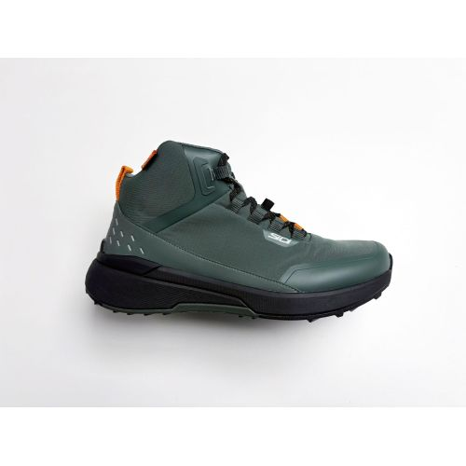
NUCLEUS | BLACK WHITE | MNUCLEUSBLKWTE | 189,95 €

NUCLEUS | IVY BLACK | MNUCLEUSIVYBLK | 189,95 €

NUCLEUS | LEMON BLACK | MNUCLEUSLEMONBLK | 189,95 €
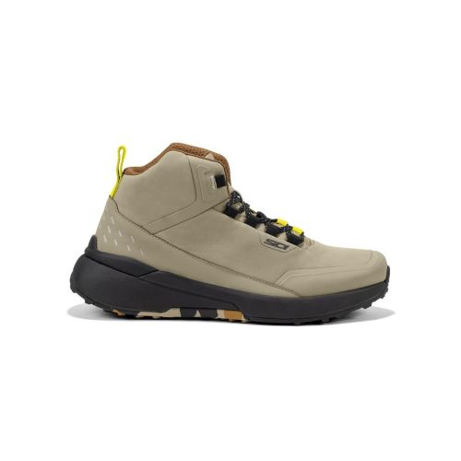
ARX WP | BLACK WHITE | MARXWPBLKWTE | 199,95 €
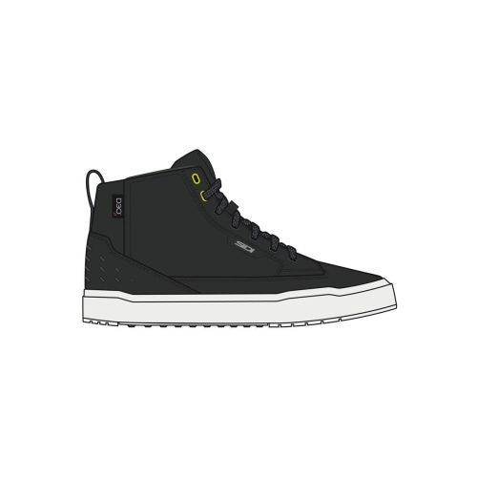

ARX WP | FULL BLACK | MARXWPFULLBLK | 199,95 €

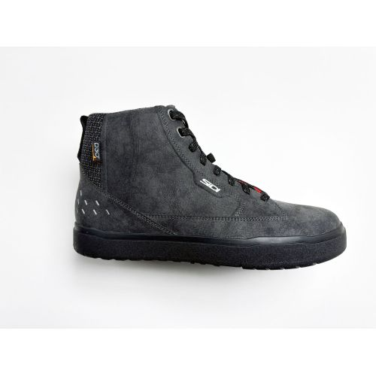
ARX WP | IVY CASTLE | MARXWPIVYCASTL | 199,95 €
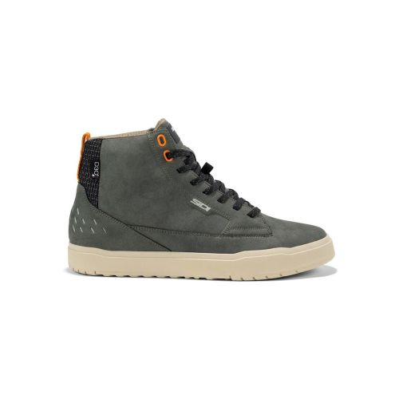
ARX | BLACK BEECH | MARXBLKBEECH | 189,95 €
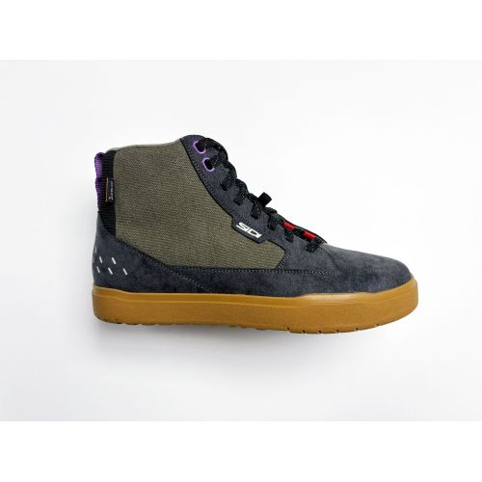
ARX | BLACK WHITE | MRARXBLKWTE | 189,95 €
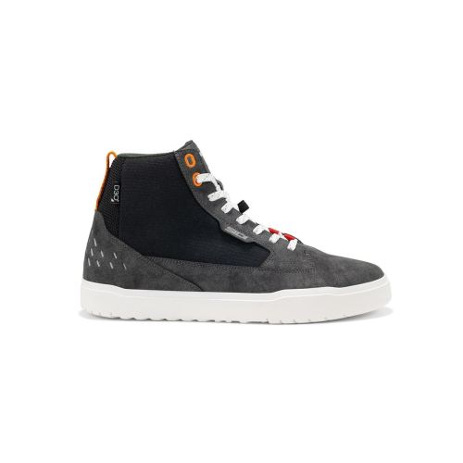
ARX | FULL BLACK | MARXFULLBLK | 189,95 €
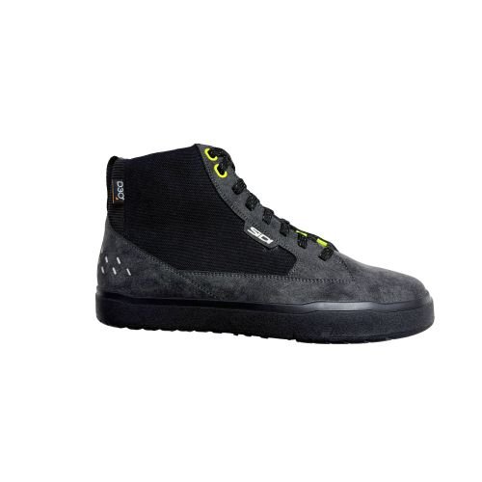
ARX AIR | BLACK BRONZE | MARXAIRBLKBRONZ | 179,95 €
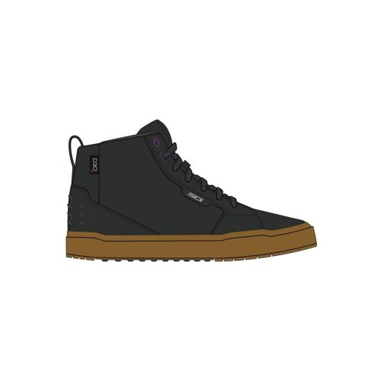
ARX AIR | BLACK WHITE | MRARXAIRBLKWTE | 179,95 €
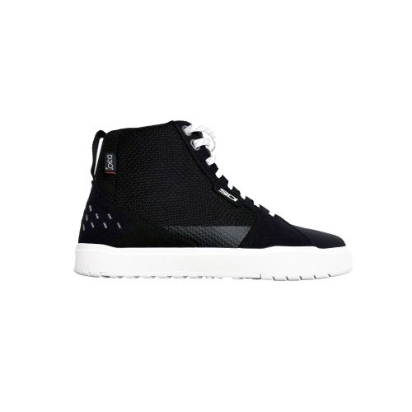
ARX AIR | CASTAIN BRONZE | MARXAIRCASTBRON | 179,95 €
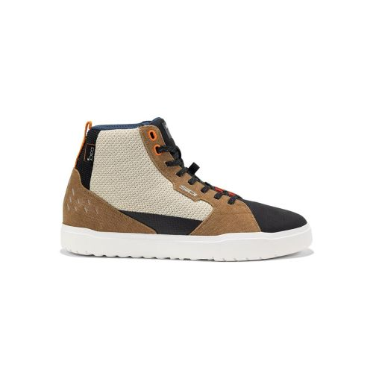
ARX AIR | LEMON PEPPER IVY | MARXAIRLEMONIVY | 179,95 €
