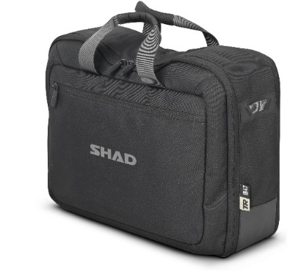
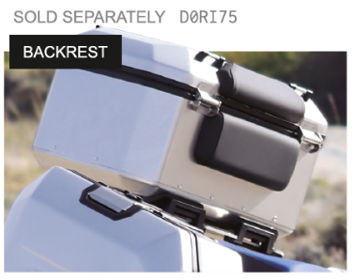
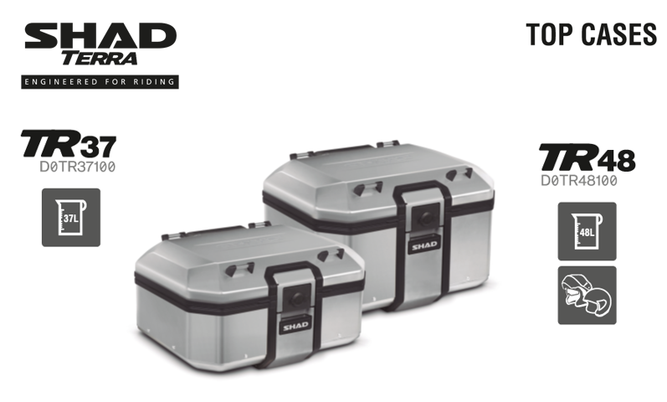

Ref | Description | TTC | PREVISION CLIENTS
D0BTR48100 | TOP CASE TERRA SH48 | 365.00 €
D0BTR37100 | TOP CASE TERRA SH37 | 335.00 €
D0RI75 | DOSSERET TERRA | TBC
X0IB47 | SACOCHE INTERNE TERRA | TBC

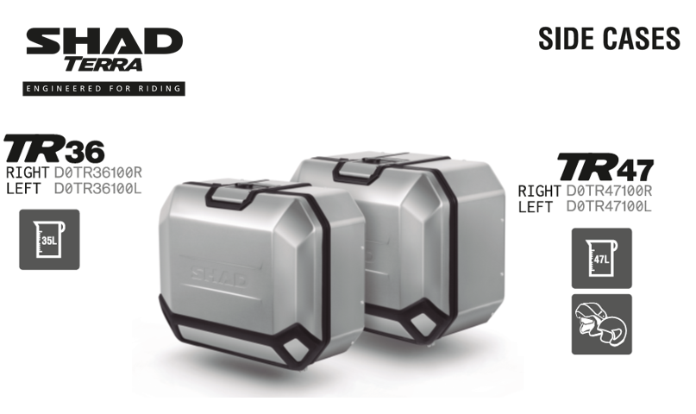

Ref | Description | TTC | PREVISION CLIENTS
D0TR36100R | VALISE LATERAL TERRA 36L DROIT | 355.00 €
D0TR36100L | VALISE LATERAL TERRA 36L GAUCHE | 330.00 €
D0TR47100R | VALISE LATERAL TERRA 47L DROIT | 380.00 €
D0TR47100L | VALISE LATERAL TERRA 47L GAUCHE | 355.00 €

NEW 4P FITTING KITS

# | BRAND | MODEL | YEAR | AVAILABILITY
 | BMW | R 1250 GS / ADV / R 1200 GS | 2018-2020 | 22-FEB-20
 | HONDA | AFRICA TWIN | 2018-2019 | 22-FEB-20
 | SUZUKI | DL 650 V-STROM | 2017-2019 | 22-FEB-20
 | SUZUKI | V-STROM 1000 | 2014-2019 | 22-FEB-20
 | HONDA | AFRICA TWIN | 2020 | 22-FEB-20
 | HONDA | AFRICA TWIN ADV | 2020 | 22-FEB-20
 | YAMAHA | TENERE 700 | 2019 | 22-FEB-20
 | BMW | R1200GS | 2013-2018 | 22-FEB-20
 | BENELLI | BENELLI TRK X'18 | 2018-2019 | 22-FEB-20
 | KTM | 1290 SUPER ADVENTURE | 2014-2019 | 22-FEB-20
 | KTM | 790 ADVENTURE R | 2019 | 22-FEB-20
 | MOTO GUZZI | MOTO GUZZI V85 | 2019 | 22-FEB-20

# | BRAND | MODEL | YEAR | AVAILABILITY
 |  | NEW 1 | 2020 | 1 HALF 2020
 |  | NEW 2 | 2020 | 1 HALF 2020
 |  | NEW 3 | 2020 | 1 HALF 2020
 |  | NEW 4 | 2020 | 1 HALF 2020
 | YAMAHA | TRACER 900 / GT | 2018-2019 | 1 HALF 2020
 | YAMAHA | TRACER 900 | 2015-2017 | 1 HALF 2020
 | BMW | F800GS / F 650 GS / F 700 GS | 2008-2018 | 1 HALF 2020
 | BMW | F750GS / F850GS | 2018-2019 | 1 HALF 2020
 | HONDA | NC 750 X | 2016-2019 | 1 HALF 2020
 | HONDA | X-ADV 750 | 2017-2019 | 1 HALF 2020
 | YAMAHA | TRACER 700 / GT | 2016-2019 | 1 HALF 2020
 | DUCATI | MULTISTRADA 1260 /ENDURO | 2018-2019 | 1 HALF 2020
 | KAWASAKI | VERSYS 650 | 2015-2019 | 1 HALF 2020
 | TRIUMPH | TIGER 800 | 2011-2019 | 1 HALF 2020

